User

Manual

Recovery Module

**Version 6.1**

|  |  |
| --- | --- |
| ***Corporate Office*** | ***Offshore Development Center*** |
| *1 Pickering Street*  *#06-03 Great Eastern Centre*  *Singapore 048659* | *Plot # 122 & 123, N.S.E.Z, Phase -2*  *NOIDA, UP 201 305*  *India*  *Tel: 91.11.91.2510483* |

|  |  |  |  |  |
| --- | --- | --- | --- | --- |
| **Author** | | | | |
| **Name** | **Role** | **Date of Preparation** | **Signature** | |
| Varun Gupta | Business Analyst | 30-Jan-2015 | Varun | |
| **Reviewer(s)** | | | | |
| **Name** | **Role** | **Date of Review** | **Signature** | |
| Pravesh Kumar | Manager Projects |  |  | |
|  |  |  |  | |
| **Approver** | | | | |
| **Name** | **Role** | **Date of Approval** | **Signature** | |
| ChengChoon Yip | VP Ebix Exchange  Asia |  |  | |
| **Document Path** | **Version Number** | **Date of Release** | | |
|  | 2.4 | 5 March 2015 | | |
|  | 4.0 | 31st March 2015 | | |
|  | 5.0 | 1 April 2015 | | |
|  | 5.1 | 15 April 2015 | | |
|  | 5.2 | 11 May 2015 | | |
|  | 6.0 |  | | |
|  | 6.1 | 8 July 2015 | | |
| **Revision History** | | | | |
| **Version Number** | **Date of Release** | **Section/ Page # Changed** | | **Details of Changes** |
| 1.0 | 5 March 2015 | Created document for system admin module | | Whole document Created |
| 4.0 | 31st March 2015 | 23 / 115 | | Added upload module |
| 5.0 | 1 April 2015 | Whole document | | Changed sequence of Menus as per actual system admin master sequence. |
| 5.1 | 15 April 2015 | 5.1.4 Select Permission List Screen | | Updated as per latest requirement of security management |
| 5.2 | 11 May 2015 | Section 12, 13 and 28 | | FAL, Common master manual and LOG Request module’s user manual added |
| 6.0 | 1 July 2015 | New Recovery section | | Removed all sections and added Recovery Module |
| 6.1 | 8 July 2015 | Entire document | | Edited sentences throughout the document. |

|  |  |  |
| --- | --- | --- |
| **References** | | |
| **Document** | **Date Received** | **Author** |
|  |  |  |

Contents

1 Recovery Module 4

1.1 Recovery for OD Claim Type 4

1.1.1 Grid Screen 4

1.1.2 Add recovery Screen 5

1.1.2.1 Add recovery fields information 5

1.1.3 OD Grid screen after processed 6

1.1.4 View OD Recovery Screen 7

1.2 Recovery for BI Claim Type 7

1.2.1 Grid Screen 7

1.2.2 Add Recovery screen : 8

1.2.2.1 Field information for BI claim recovery 8

1.2.3 View Recovery Screen 9

# Recovery Module

* **Description:** 
  + Recovery transaction can be performed on Recovery tab screen within the Claim Registration menu.
  + Recovery module is applicable for OD and BI Claims only.
  + For OD claim, user can do recovery after mandate approval of a particular claim.
  + For BI Claim, user can do recovery after payment approval of a particular claim.

## Recovery for OD Claim Type

### Grid Screen for OD claim

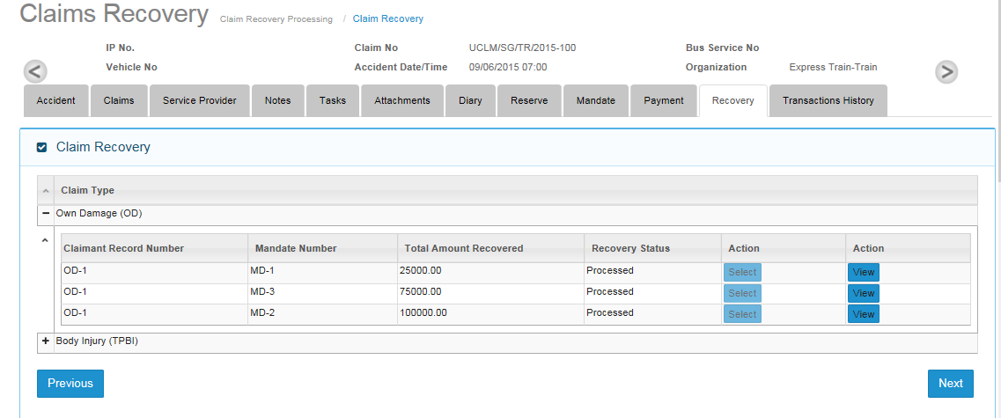

* Grid screen for OD claim will be updated after mandate approval of OD claim.
* Clicking on the Select button will show Add recovery screen for OD Claim.

### Add recovery Screen

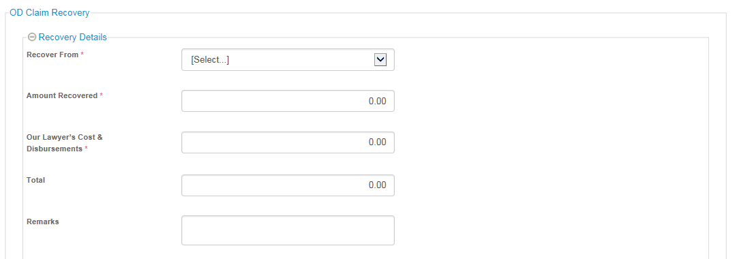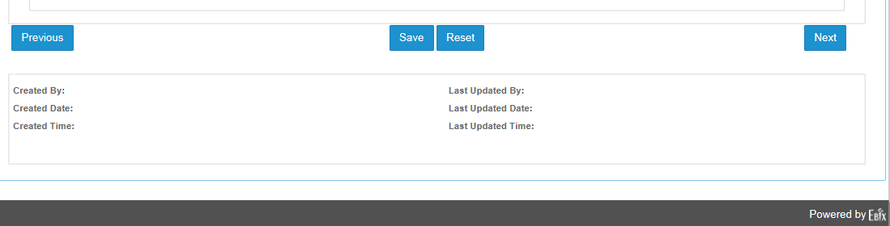

#### Add recovery fields information

|  |  |  |  |  |  |  |
| --- | --- | --- | --- | --- | --- | --- |
| **Field** | **Field Format** | **Field Size** | **Mandatory** | **Non-editable once user land on screen** | **Editable after Saving** | **Remarks** |
| Recover From | Alpha-numeric | 250 Chars | Y | N | N | Data populated from Claimant’s Name and Service Providers created for the OD claim.  Example:  Claimant’s Name = James Tan  Insurer = AXA Insurance  Recover From will have the following input selection for user to choose from:  James Tan  AXA Insurance |
| Remarks | Alpha-numeric | 500 Chars | N | N | Y | Free text field for user to enter comments |
| Amount Recovered | Numeric | 999,999,999.99 | Y | N | Y | Numeric Field for user to enter |
| Our Lawyer’s Cost & Disbursements | Numeric | 999,999,999.99 | Y | N | Y | Numeric Field for user to enter |
| Total | Numeric | 999,999,999.99 | System calculated | Y | N | 1. Total = Amount Recovered + Our Lawyer’s Cost & Disbursements 2. Amount entered is check against the approved mandate. Total amount cannot be less than approved mandate. |

* After clicking on the Save button, Recovery status will be changed to “Processed”. User can view the recovery entry and cannot do any further modifications on that record.

### OD Grid Screen after Recovery Status has been changed to “Processed”

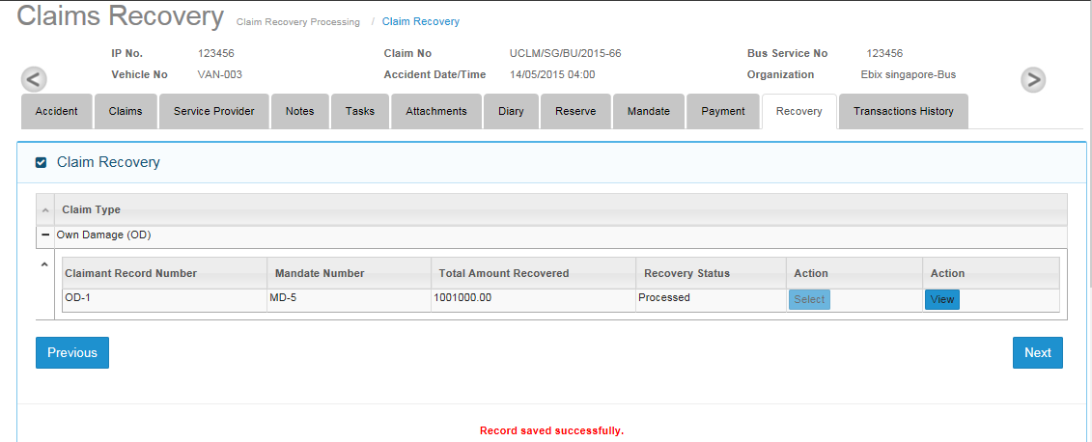

### OD Recovery Screen in View Mode

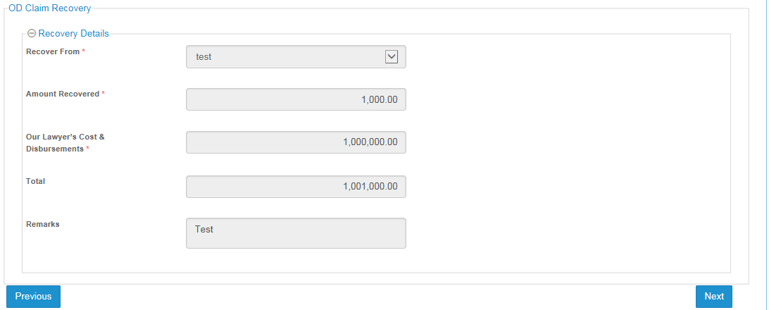

## Recovery for BI Claim Type

* One entry of BI claim type moves to Recovery tab if payment has been approved.

### Grid Screen

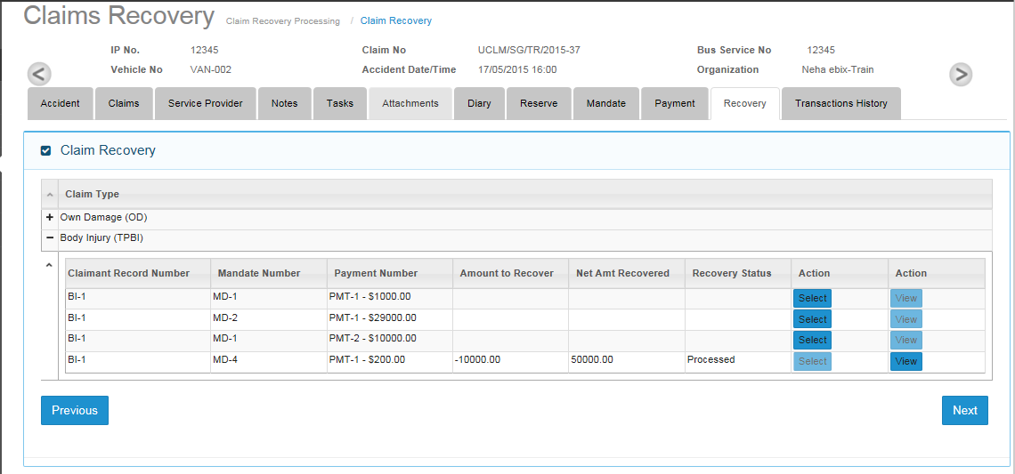

* Whenever payment request has been approved for BI claimant, the Recovery tab grid will be updated for the same record.
* Recovery can be done for multiple BI Claims in a batch for the first time. Subsequent payment recovery can be done for each new approved BI Claim payment.
* Batch will be formed as per following formula:
  + Total amount of payment for BI claims > Deductible amount

For example:

* + - Deductible is $10000.
    - BI-1 : 5000, BI-2 : 3000, BI-3 : 5000
      * For Claim BI-1 and Claim BI-2, user will not be able to start the recovery process the as total (5000+3000 = 8000) is less than the deductible amount
      * When BI-3 appears in the recovery grid, recovery process can begin as the total for 3 BI Claims has exceeded the deductible amount.

### Add Recovery screen:

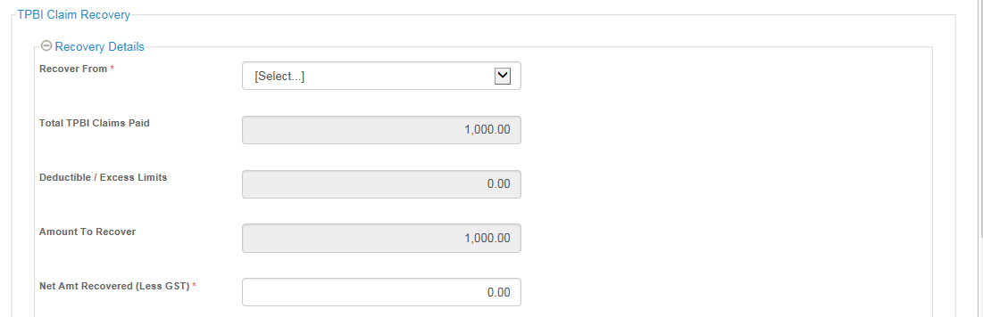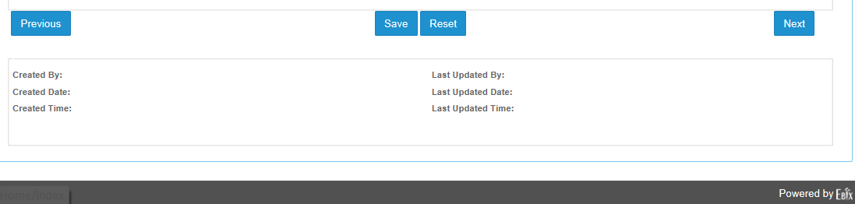

#### Field information for BI claim recovery

|  |  |  |  |  |  |  |
| --- | --- | --- | --- | --- | --- | --- |
| **Field** | **Field Format** | **Field Size** | **Mandatory** | **Non-editable once user land on screen** | **Editable after Saving** | **Remarks** |
| Recover From | Alpha-numeric | 250 Chars | Y | N | N | Data populated from Insurer master table with Insurer type = Own and Both. |
| Total TPBI Claims Paid | Numeric | 999,999,999.99 | System Generated | Y | N | This is pulled from the total values of TPBI Claims Payment |
| Deductible / Excess Limit | Numeric | 999,999,999.99 | System Generated | Y | N | Deductible tagged to the Organization for the Claim that is created will be fetched and displayed in this field |
| Amount to recover | Numeric | 999,999,999.99 | System Generated | Y | N | Value = Total TPBI Payout – Deductible |
| Net Amt Recovered (Less GST) | Numeric | 999,999,999.99 | Y | N | Y | User input. |
| Remarks | Alpha-numeric | 500 Chars | N | N | Y | Default to “Deductible Exceeded” |

### View Recovery Screen

* User can view processed BI claim recovery entry record in non-editable mode by clicking on view button on grid screen.

